
Name: _________________________________

Task 8:

SOURCE ANALYSIS, FORTNIGHTLY TASK FOUR Weighting 2% (9 Marks)

Question 1

- Explain the message of Source 1.
(3 marks)

2. Identify how and discuss why Sources 1 and 2 are contestable.
(6 marks)

Source 1:
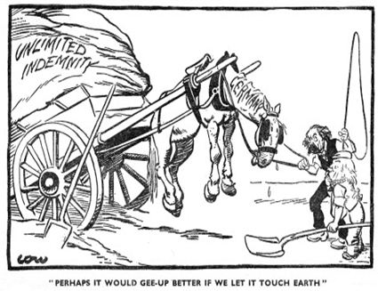

The source above is a cartoon which was published in the British newspaper “The Star” in January 1921. The cartoon was created by David Low a British artist.

Source 2:

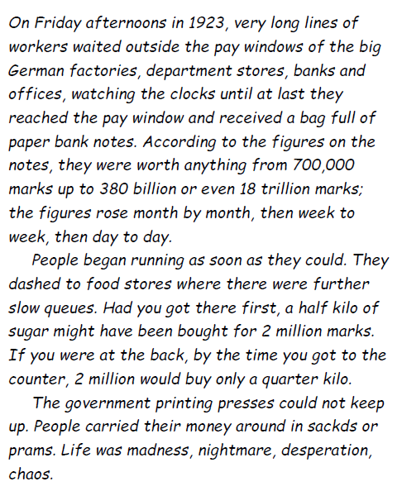

The source above is an extract from K. Heiden, Der Fuhrer: Hitler’s Rise to Power, 1944.
Heiden was a German democrat who lived through Weimar and Nazi Germany; he carefully collected evidence to use in his anti-Nazi writings.

